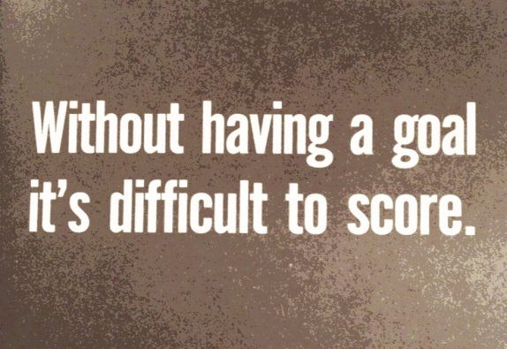

Progress made towards my goal. 1 = I am just getting started, 10 = I have made it!

Remember progress is the most important thing!

First session: 1 2 3 4 5 6 7 8 9 10

Review: 1 2 3 4 5 6 7 8 9 10

Last session: 1 2 3 4 5 6 7 8 9 10

Name ……………………………………………………………………….date set……………………………………….date reviewed…………..

Date achieved……………………………………………………………